MATHANKUMAR.M

1911402

1.Create a Bucket in IBM object storage.

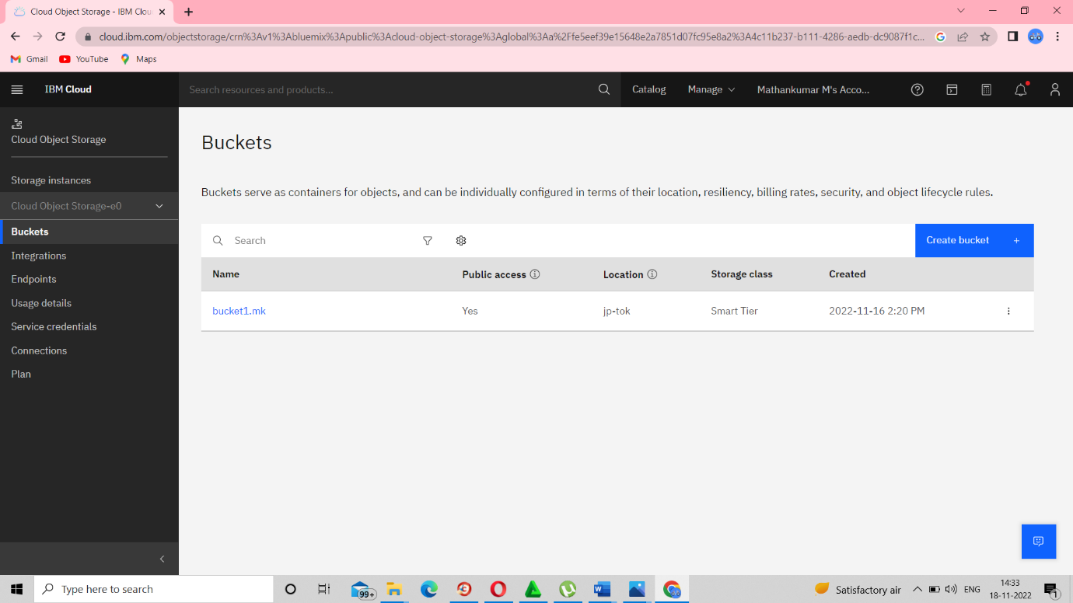

2.Upload an 5 images to ibm object storage and make it public. write html code to displaying all the 5 images.

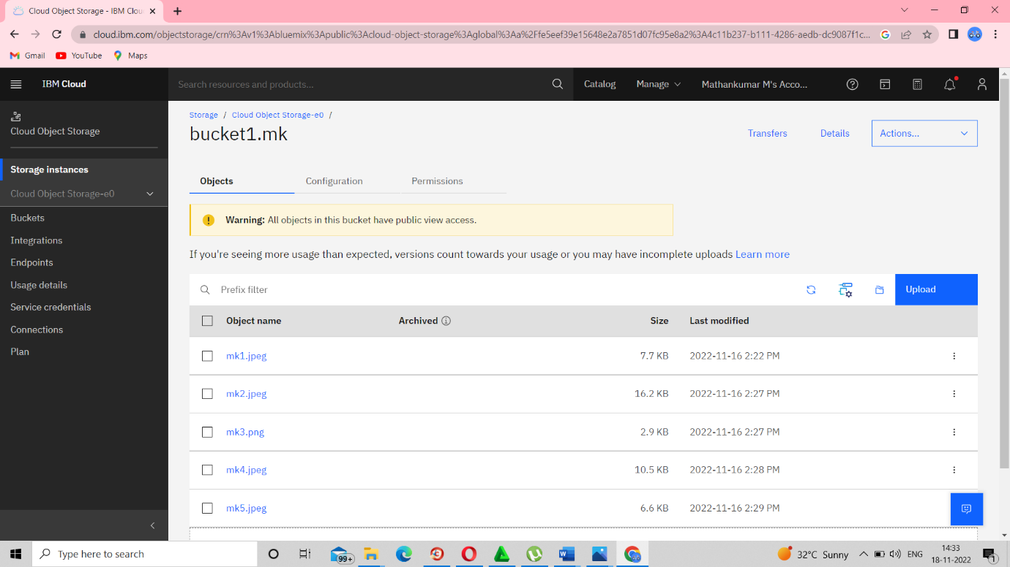

4.Design a chatbot using IBM Watson assistant for hospital. Ex: User comes with query to know the branches for that hospital in your city. Submit the web URL of that chat bot as a assignment

<https://web-chat.global.assistant.watson.appdomain.cloud/preview.html?backgroundImageURL=https%3A%2F%2Fau-syd.assistant.watson.cloud.ibm.com%2Fpublic%2Fimages%2Fupx-671b27a1-3379-474a-b987-072d0f9f2aab%3A%3A7549c4a2-4db6-4aa3-8fda-1ce7b9e89bf8&integrationID=23887650-0a2c-43ae-8ee0-a64a90ad177a&region=au-syd&serviceInstanceID=671b27a1-3379-474a-b987-072d0f9f2aab>